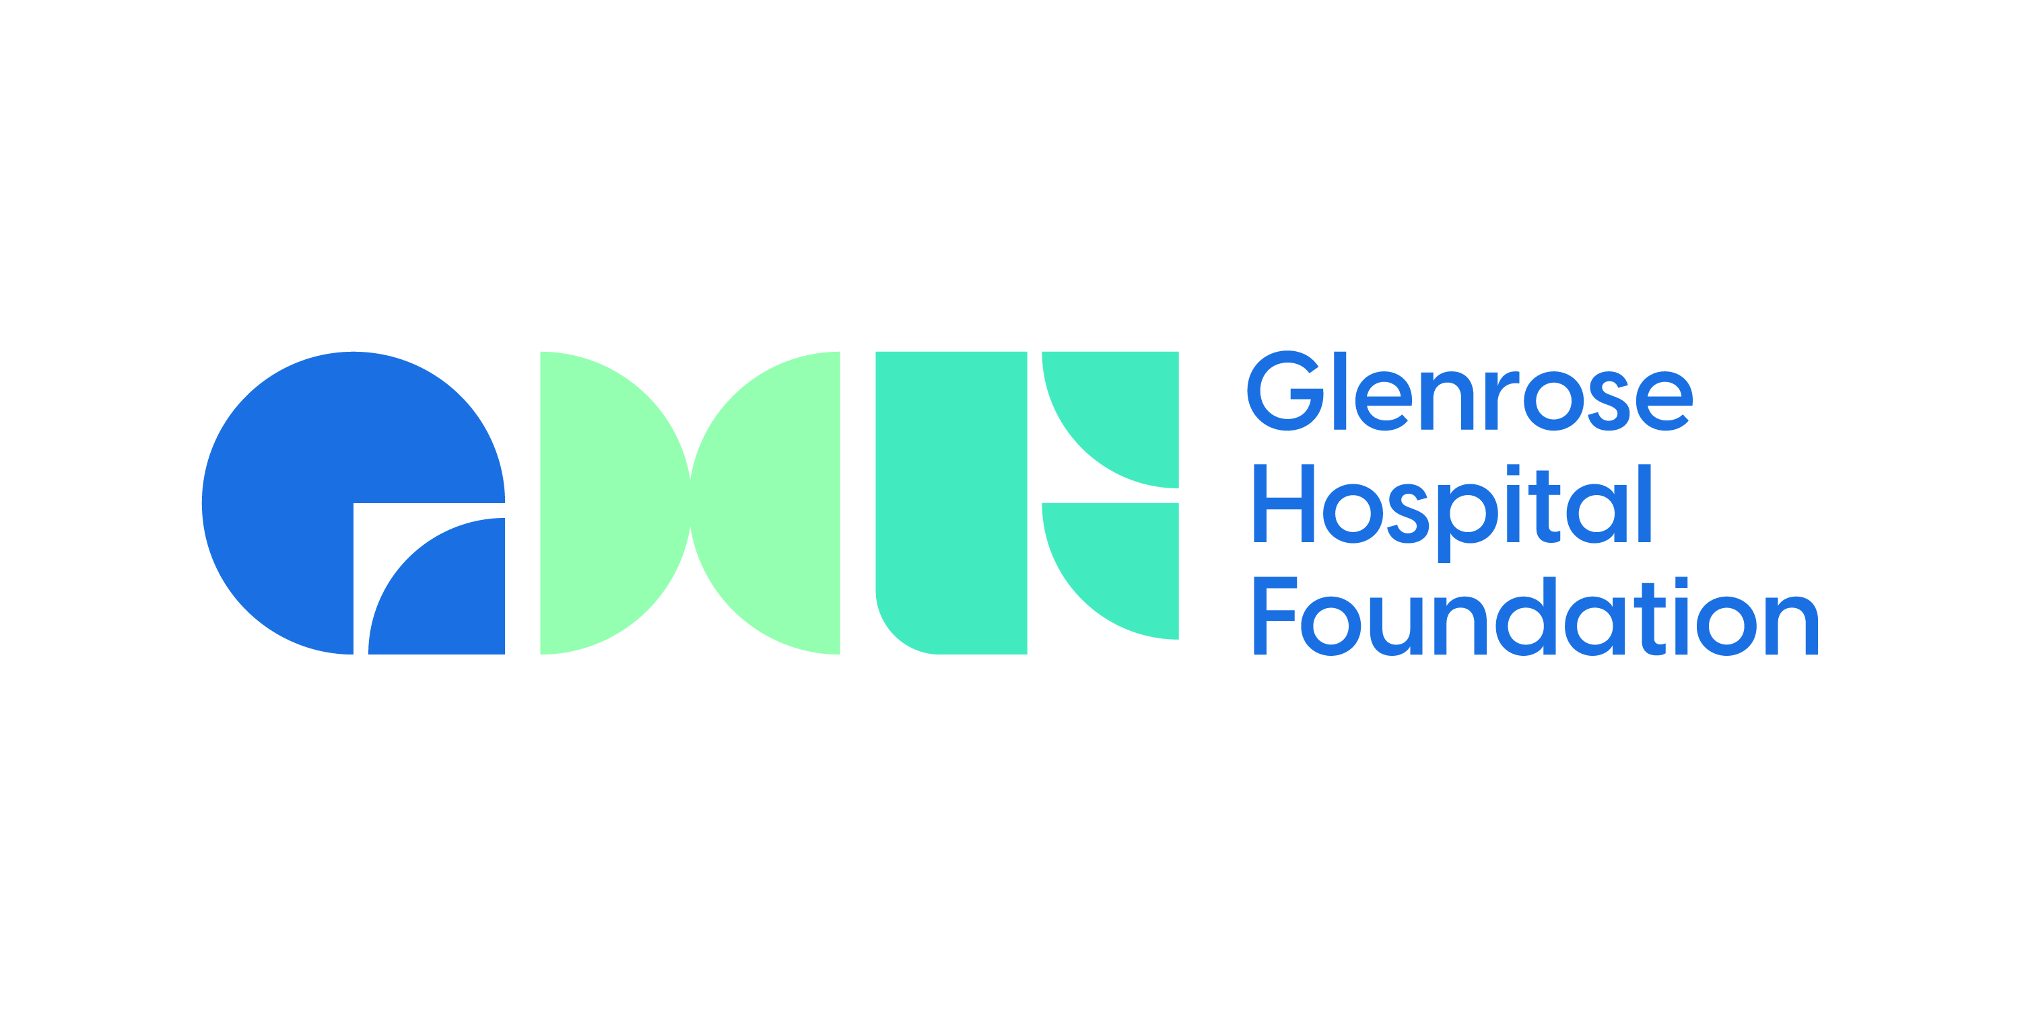

**Manager, Communications and Engagement**

**ABOUT THE GLENROSE HOSPITAL FOUNDATION:**

**Vision**

To reimagine human ability.

**Mission**

We mobilize resources to accelerate advances in human ability.

**THE OPPORTUNITY:**

Reporting directly to the Vice President, the Manager of Communications & Events holds the responsibility of formulating and attaining the communication goals while providing support for fundraising efforts at the Glenrose Hospital Foundation. This role involves the creation of a strategic communication, marketing, and engagement blueprint for the foundation and serves as a pivotal contributor to enhancing its visibility, engaging donors, and bolstering its reputation. The ideal candidate will additionally manage media and public relations initiatives, cultivate connections with external media outlets, compose press releases, develop briefings, and craft speaking notes and scripts.

**KEY RESPONSIBILITIES:**

* Develop and execute a creative annual communications plan, including events and projects, in alignment with key strategic priorities
* Identify and recommend opportunities to increase visibility and educate the community about the activities and progress of the Glenrose Hospital and Foundation.
* Anticipate and respond to emerging issues that require communications support.
* Orchestrate major events that boost fundraising efforts and raise the profile of the Foundation.
* Responsible for all marketing and communications needs for events
* Retain, recruit, and manage a team of professionals and consultants with an appropriate balance of skills and experiences; establish work plans, performance objectives and goals; and regularly review performance.
* Develop and implement an effective social media plan
* Ensure consistency in messaging, style, voice, and content for all communication materials, including reports, collateral, website, and other electronic media.
* Build relationships with the media, vendors and other stakeholders in the community.
* Implement processes and analyze operational results analysis to deliver accurate and timely reports regarding communication and fundraising activities and results.
* Write, edit, and proofread content as needed.
* Establish and proactively manage budgets for the communications and philanthropy department.
* Other duties as assigned.

**SKILLS AND QUALIFICATIONS:**

* Bachelor's degree in a related discipline. A combination of education and experience will be considered.
* 5+ years of non-profit fundraising and communications experience
* Strong research and analytical skills
* Demonstrated skills in motivating, directing and managing staff and consultants A strong donor-centric philosophy and approach to fundraising/philanthropy
* Solid knowledge of ethical principles and best practices relating to fundraising, prospect research, donor relations and communications.
* An exceptional communicator
* Ability to drive the mission and priorities of the Glenrose Hospital Foundation
* Excellent time and resource management skills. Ability to handle multiple ongoing initiatives and prioritize the team's work to meet deadlines.
* Valid driver’s license and ability to travel occasionally.

**Employment Details**

Hours and Location of Work

This is a full-time, permanent position. Hours of work are typically during the day, Monday – Friday, with occasional evenings and weekends. This is a hybrid position, where the incumbent is expected to be in-office 1-2 days per week.

**Compensation**

We offer a comprehensive compensation package, including benefits, professional development and generous paid time off. The salary range for this role is between $75,000 - $90,000 annually.

Equal Opportunity

The Glenrose Foundation is an equal opportunity employer. We welcome applications from all candidates. We value the diversity of the people we hire and serve. Diversity at the Glenrose Foundation means fostering a workplace in which individual differences are recognized, appreciated and respected, and responded to in ways that fully develop and use each person's talents and strengths.

**Applying**

**Please submit your cover letter and resume to info@GlenroseFoundation.com**

**Resumes will be screened as they are submitted, and interviews will be conducted on an ongoing basis. This posting will remain open until October 13, 2023, or until a suitable candidate is found.**